LaCie 10TB d2 Professional USB-C 3.2 Gen 2 External Hard Drive

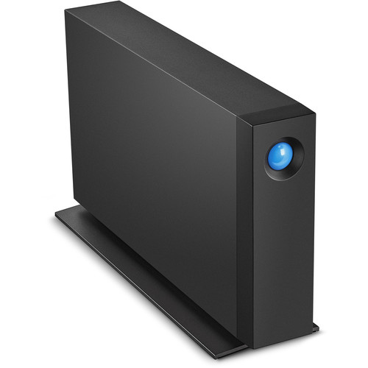

**Key Features**

* **Storage Capacity**: 10TB, perfect for storing high-resolution photos, videos, and extensive project libraries.
* **Performance**:
  + Up to **240 MB/s** for efficient file transfers and smooth editing workflows.
* **Interface**: USB-C 3.2 Gen 2, compatible with Thunderbolt 3, USB-C, and USB-A devices (adapter included).

**Compatibility**

* Works seamlessly with both Windows and macOS (pre-formatted as exFAT for universal compatibility).
* Compatible with Time Machine for macOS users and third-party backup solutions on Windows.

**Warranty and Support**

* **Warranty**: Backed by a **5-year limited warranty** for long-term peace of mind.
* **Rescue Data Recovery Services**: Includes 5 years of professional data recovery services in case of unexpected data loss.